**Vertical partitioning in Amazon DynamoDB using AWS Glue**

**Step -1 :** Download the necessary json file from the data source

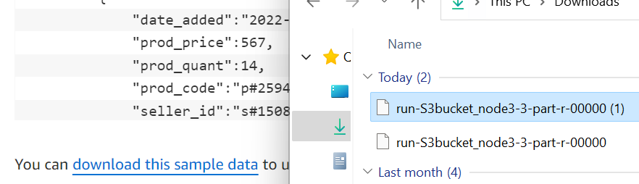

**Step – 2 :** Create an S3 Bucket and upload the downloaded json file into the newly created S3 Bucket

**Step – 3 :** Go to AWS Glue and the navigate to Crawlers. Then click on create Crawler

**Step – 4 :** Then give the data source as newly created S3 bucket

**Step – 5:** Create IAM Role and add additional permission as DynamoDB full access, along with s3 full access.

**Step – 6 :** Create a database inside the AWS Glue and give it a name.

**Step – 7 :** After creating the database, give it as destination source in the output configuration.

**Step – 8 :** The click on OK and then click on Create Crawler.

**Step – 9 :** After the crawler is created, click the crawler and then click run.

**Step – 10 :** After the crawler is completed, its status should be changed to completed.

**Step – 11 :** Now, go to the database, which was created earlier. Check if the table is created.

**Step – 12 :** Check inside the table, and see whether the json is converted into table format.

**Step – 13 :** Now, go to ETL jobs, create spark script.

**Step – 14 :** Now, create a DynamoDB table with name **orders_vertically_partitioned**, with partition key : order_id and sort_key : SK

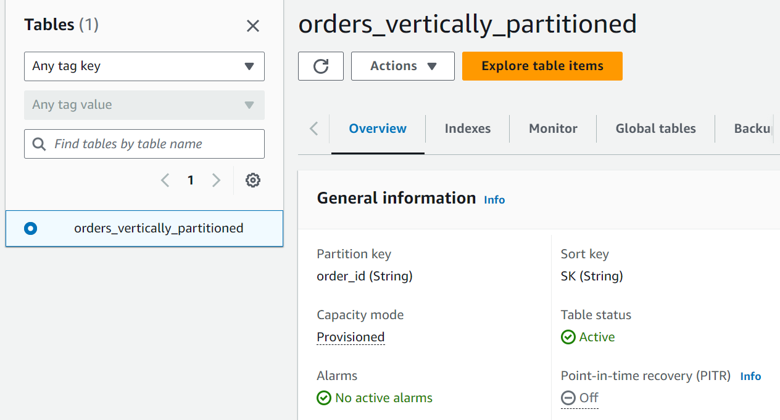

**Step – 15 :** Now, insert the code inside the spark script, and then edit the database name and table name inside the script.

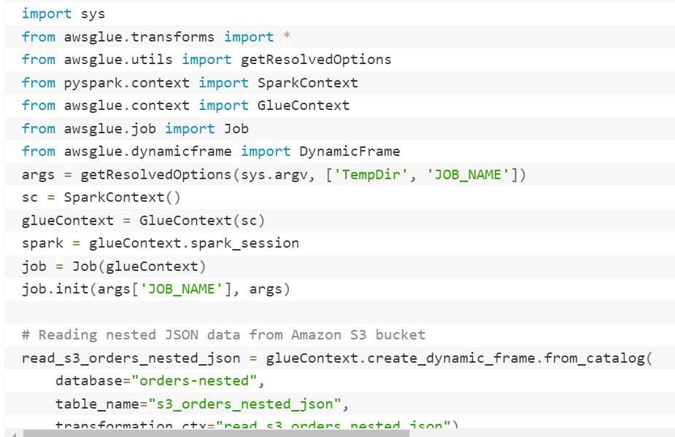

**Step – 16 :** Now, save the script and then click on Run.

**Step – 17 :** Go to DynamoDB, then click on Explore items. Navigate to **items returned.** Now you can see the items from json converted into structured format.

